**DNA FINGERPRINTING**

**Term Paper**

**Submitted**

**To the**

**University of LUCKNOW**

**BY**

**Name: SADIQA SIDDIQUI**

**B.Sc. (Bio) Semester VI**

**LU Roll No.: 2210454010298**



**DEPARTMENT OF ZOOLOGY**

# LUCKNOW CHRISTIAN DEGREE COLLEGE

**GOLAGANJ, LUCKNOW**

**2024-2025**

## ACKNOWLEDGEMENT

I would like to express my heartful gratitude to the following, without whose help this assignment would not be possible.

First to my Supervisor Associate Professor **Dr. Naveen Singh** who was always leading me in my work and helping me finish this report/thesis within time. I

thank them from the bottom of my heart for their kindness, inspiration and for the pain they took in getting this task accomplished.

I would also thank my guides for helping me out with this project and with their help I was able to complete this task perfectly. I would also like to thank my batchmates for helping me out with this project.

Last but not the least, I would like to thank my parents who did everything at their command to give me the best. If I find any success, I owe it all to them.

And most of all to God, who gave me enough knowledge and patience to think about this report/thesis and the perseverance and determination to continue this assignment despite the struggles that came in my way.

**Date: SADIQA SIDDIQUI**

**Place: B.Sc. V semester (zoology)**

**TABLE OF CONTENTS**

1. Introduction
2. Review of literature
3. Conclusion
4. Summary/abstract
5. References

### INTRODUCTION

DNA fingerprinting, also known as DNA profiling or genetic fingerprinting, is a powerful molecular technique used to identify individuals based on their unique genetic makeup. First developed in 1984 by British geneticist Sir Alec Jeffreys, this method analyzes specific regions of the DNA that vary greatly among individuals, known as variable number tandem repeats (VNTRs) or short tandem repeats (STRs). Because no two people (except identical twins) have the same DNA sequence, DNA fingerprinting has become an invaluable tool in forensic science, paternity testing, genetic research, and even biodiversity conservation. The accuracy and reliability of DNA fingerprinting have revolutionized the way identity is established, providing objective evidence in both criminal investigations and civil disputes. As advances in genetic technology continue, DNA fingerprinting is becoming faster, more affordable, and even more widely used in various scientific and legal contexts.

**History of DNA Fingerprinting**

The concept of DNA fingerprinting was first introduced in 1984 by Sir Alec Jeffreys, a geneticist at the University of Leicester in the United Kingdom. While studying genetic markers in human DNA, Jeffreys discovered that certain regions of the DNA exhibited a high degree of variability from person to person. These regions, later identified as variable number tandem repeats (VNTRs), provided a unique pattern for everyone. Early studies emphasized the forensic potential of VNTRs technology, particularly following its first application in the Colin Pitchfork case in the UK, where DNA evidence was used to secure a criminal conviction. His groundbreaking discovery came when he successfully used these patterns to distinguish between individuals, including members of the same family. The first practical application of DNA fingerprinting occurred in 1985, when Jeffreys helped solve an immigration case by proving the familial relationship between a boy and his family using genetic evidence. Shortly after, in 1986, DNA fingerprinting was used in a criminal investigation for the first time to exonerate a suspect and convict the actual perpetrator in a double murder case in England. Since then, the technique has rapidly evolved with the development of polymerase chain reaction (PCR) and the use of STRs, making DNA profiling more efficient, faster, and applicable even to very small or degraded samples. Over the years, it has become a standard tool in forensic science and many other fields, with its credibility firmly established in courts and research institutions worldwide.

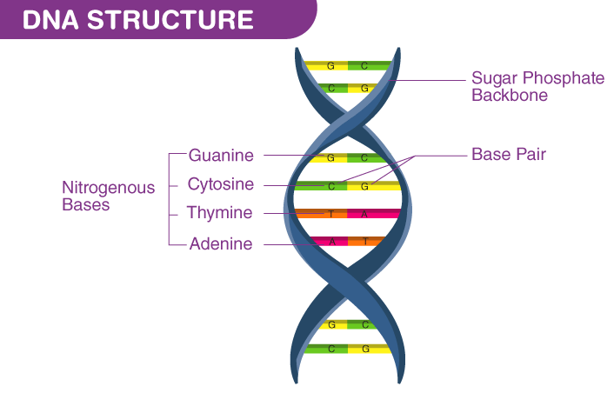

**Working Principle of DNA Fingerprinting**

The working principle of DNA fingerprinting is based on the analysis of specific regions within the human genome that vary greatly between individuals. These regions often contain sequences known as short tandem repeats (STRs), which are short sequences of DNA that repeat a variable number of times in different individuals. The core idea is to extract and examine these repeating sequences to create a unique genetic profile for each person.

The process begins with the extraction of DNA from a biological sample, such as blood, saliva, hair, or skin cells. Once the DNA is isolated, it is amplified using a technique called polymerase chain reaction (PCR), which allows scientists to make millions of copies of the targeted STR regions. The amplified DNA is then separated and visualized using gel electrophoresis or capillary electrophoresis, which sorts the DNA fragments based on their size. Everyone has a unique pattern of STR lengths at multiple loci, and by analyzing several of these loci, a distinctive DNA profile is created.

This profile can then be compared with DNA profiles from other samples to determine identity or biological relationships. Because the probability of two unrelated individuals having the same DNA fingerprint is extremely low, especially when multiple STR loci are analyzed, this method provides high accuracy and reliability in identification. The advancement of automated DNA sequencing and database technology has further improved the speed and precision of this process, making DNA fingerprinting a cornerstone of modern genetic and forensic science.

### REVIEW OF LITERATURE

**DNA Fingerprinting:**

DNA fingerprinting, also known as DNA profiling, is a molecular technique used to identify individuals based on their unique genetic makeup. Since its introduction by Alec Jeffreys in 1985, the technique has undergone significant advancements and has become a critical tool in forensic science, paternity testing, and human identification.

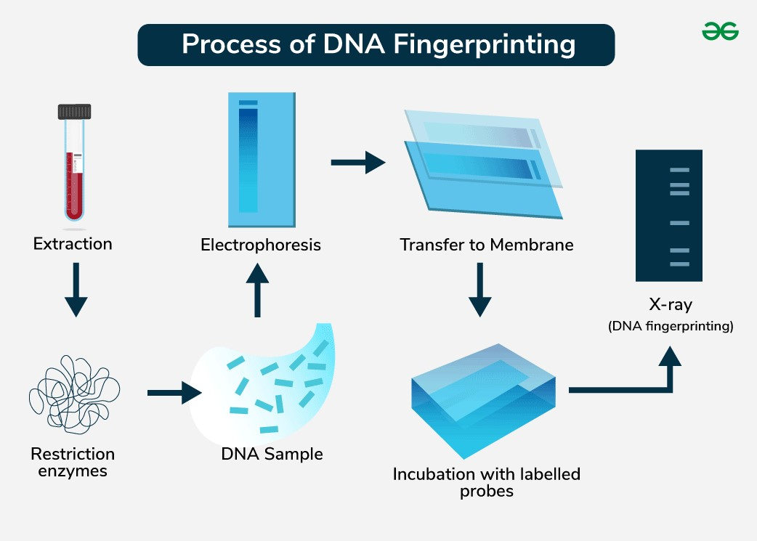

### • Technological Advancements

Early DNA fingerprinting techniques, such as **Restriction Fragment Length**

**Polymorphism (RFLP)**, required relatively large, intact DNA samples and

took considerable time to analyze. **Polymerase Chain Reaction (PCR)**, developed by Mullis and Faloona (1987), revolutionized the field by allowing the amplification of tiny DNA samples, making DNA profiling more accessible and efficient. PCR’s widespread use in forensic DNA profiling was solidified in the 1990s, particularly with the advent of **Short Tandem Repeat (STR)** analysis, which utilizes loci that exhibit high variability between individuals (Butler, 2005). STR markers are now the standard for forensic DNA profiling due to their high discrimination power and shorter analysis times.

The introduction of **Capillary Electrophoresis** further enhanced DNA analysis, offering automated and precise separation of STR alleles. This shift from traditional gel electrophoresis to capillary-based systems made largescale, high-throughput analysis feasible (Gill et al., 2006). More recently, the advent of **Next Generation Sequencing (NGS)** opened new doors in forensic genetics, enabling broader genomic analyses and even the prediction of phenotypic traits, such as hair or eye color, from a DNA sample (Budowle, Eisenberg, & Green, 2014).

### • Ethical, Legal, and Social Implications

As DNA fingerprinting technologies have expanded, so too have the ethical and legal questions surrounding their use. One of the primary concerns is the **privacy** of individuals whose genetic information is stored in national or regional DNA databases. Critics argue that the inclusion of individuals in these databases without consent infringes on privacy rights (Kaye, 2010). The debate has been particularly intense regarding the **retention of DNA profiles** of individuals not convicted of crimes, as seen in the UK’s **National DNA Database (NDNAD)**, which stores profiles from individuals even before their legal guilt or innocence is determined (Harris, 2011).

Furthermore, there are concerns about **genetic surveillance** and the **potential for genetic discrimination**. Given that DNA can reveal sensitive health information or familial relationships, the misuse of genetic data could lead to discrimination in employment, insurance, or healthcare (Krimsky, 2006). As noted by Kaye (2006), these concerns call for stringent regulations and oversight to prevent the abuse of DNA databases.

.

### • Global Perspectives

The application of DNA fingerprinting varies significantly across countries. In the United States, **CODIS (Combined DNA Index System)** provides a network of databases containing DNA profiles of criminals, missing persons, and arrestees. The system has been instrumental in solving numerous cold cases (Budowle et al., 2014). However, critics have raised concerns about the system's scope and the inclusion of innocent individuals’ DNA profiles (Kaye, 2010).

In the United Kingdom, the **National DNA Database (NDNAD)** contains millions of DNA profiles and has been a major tool in solving crimes. However, this widespread use has raised privacy concerns regarding the retention of DNA profiles from individuals who have not been convicted of any crime (Harris, 2011).

Internationally, countries such as **India** are developing their own DNA databases for forensic purposes, while many European countries have stricter regulations regarding the use of DNA evidence and the retention of genetic data. The **European Union** has implemented laws ensuring that genetic data collected in forensic contexts is used ethically, with safeguards to protect individual rights (Jobling & Gill, 2004).

### Methodology of DNA Fingerprinting (How It Is Done)

DNA fingerprinting involves a series of carefully controlled laboratory steps that work together to isolate, amplify, and analyze an individual's genetic material. The general methodology can be broken down into several key stages:

1. **Sample Collection**:

The first step involves the careful collection of biological samples that contain nucleated cells. Common sources of DNA include blood, buccal (cheek) swabs, hair follicles, semen, saliva, skin tissue, and bone. In forensic settings, trace biological evidence such as skin cells from a weapon or hair from a crime scene may be used. Proper collection techniques and the use of sterile, tamper-proof containers are essential to prevent contamination or degradation of the samples.

**Types of Biological Samples**

DNA can be extracted from a wide range of biological materials, including:

* **Blood**: Typically collected from a vein using a sterile syringe and stored in EDTA tubes to prevent clotting.
* **Buccal (cheek) cells**: Collected by swabbing the inner lining of the mouth with a sterile cotton or synthetic swab.
* **Hair**: Only hair with the root (follicle) contains sufficient nuclear DNA.
* **Saliva**: Often collected using a spitting method or swabbing the inside of the mouth.
* **Semen**: Common in forensic and paternity testing, collected using a sterile swab or absorbent material.
* **Urine, sweat, and feces**: Can contain DNA but are less reliable due to lower DNA concentrations and higher contamination risk.
* **Bone and teeth**: Used when samples are old or degraded, such as in forensic anthropology or ancient DNA analysis.
* **Nail clippings and skin cells**: May be used when other sources are unavailable.

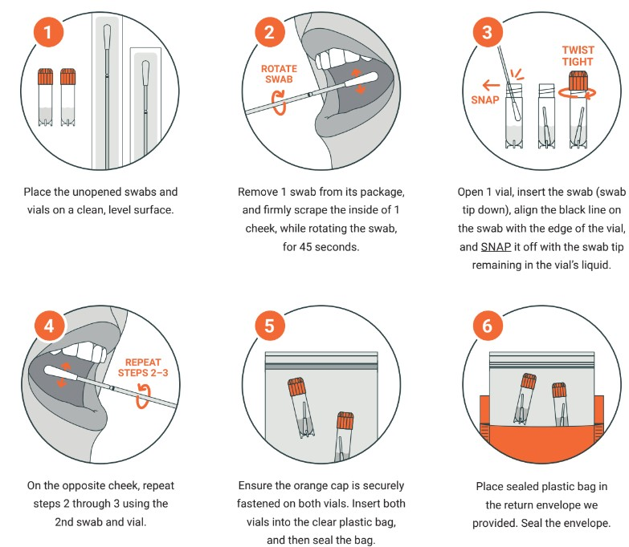

1. **DNA Extraction**:

Once the sample is obtained, the DNA must be isolated from the cells. This is typically done using chemical, enzymatic, or mechanical methods. In most standard protocols, a lysis buffer is used to break open the cells and release the DNA. Proteins and other contaminants are removed using proteases or organic solvents (like phenol-chloroform), and the DNA is precipitated using alcohol (ethanol or isopropanol). The result is purified DNA, which is then suspended in a buffer solution for further processing.

**Overview of DNA Extraction Process**

The DNA extraction process typically involves four key steps:

1. **Cell lysis** (breaking open the cells)
2. **Removal of proteins and other contaminants**
3. **DNA precipitation**
4. **DNA purification and resuspension**

**Quality and Quantity Assessment**

Once DNA is extracted, it's essential to assess its quality and quantity:

* **Spectrophotometry (Nanodrop)**:
  + DNA concentration measured at **260 nm**.
  + Purity ratio A260/A280 should be ~1.8 for pure DNA.
* **Agarose Gel Electrophoresis**:
  + Visualizes DNA integrity (high molecular weight = intact DNA).
  + Detects RNA or protein contamination.
* **Fluorometry (e.g., Qubit)**: For more accurate quantification using fluorescent dyes.

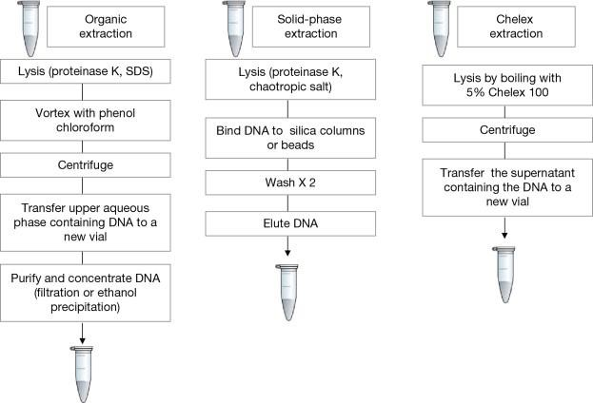

1. **DNA Quantification:**

Before amplification, it is important to quantify the extracted DNA to ensure sufficient and quality material is available for analysis. Quantification can be performed using spectrophotometry (e.g., NanoDrop), fluorometry, or real-time PCR (qPCR). This step is crucial in forensic applications where limited or degraded DNA may be present.

**Objectives of DNA Quantification**

* To determine the **concentration** of DNA in a sample.
* To assess **purity** (i.e., whether the DNA is contaminated with proteins, RNA, or chemicals).
* To ensure the **appropriate amount** of DNA is used in downstream processes.
* To check for the presence of **inhibitors** that may affect amplification.

**Quality Control Before DNA Fingerprinting**

After quantification, DNA is assessed for:

* **Concentration**: Ideal range depends on technique; for PCR, typically 1–100 ng/µL.
* **Purity**: A260/A280 ~1.8 and A260/A230 >1.8
* **Integrity**: High molecular weight, non-smeared DNA preferred

If the sample fails quality control:

* It may be **re-extracted**.
* Dilution or cleanup may be done to remove contaminants.
* DNA may be **amplified using whole-genome amplification (WGA)** if quantity is low.

**DNA Quantification in Forensic Applications**

* In forensic labs, **quantitative PCR (qPCR)** is often used as it quantifies **human-specific DNA** and can detect inhibitors.
* qPCR also helps **predict PCR success**, especially with degraded or mixed samples.

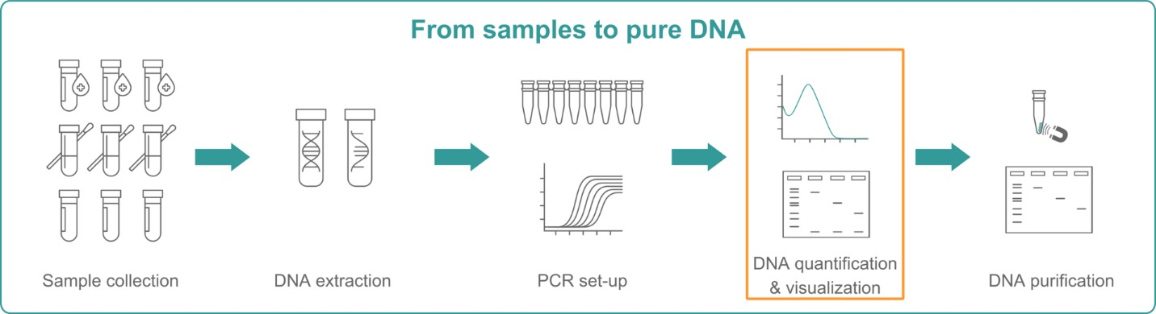

1. **DNA Amplification (Polymerase Chain Reaction – PCR)**:

In most modern DNA fingerprinting techniques, especially STR analysis, PCR is used to amplify specific DNA regions. PCR enables millions of copies of targeted STR loci to be produced in just a few hours. The process involves three main steps repeated in cycles:

* + **Denaturation** (94–98°C): The double-stranded DNA is heated to separate into two single strands.
  + **Annealing** (50–65°C): Short DNA primers bind to the specific regions flanking the STRs.
  + **Extension** (72°C): DNA polymerase extends the primers, synthesizing new DNA strands.

This cycle is repeated 25–35 times, exponentially amplifying the target DNA sequences.

**Selection of Target Regions**

* STR loci are selected because they are highly polymorphic and individual-specific.
* Commonly used STR markers include **D3S1358**, **D5S818**, **D13S317**, and **D7S820**.
* Primers are designed to flank these STR regions.

**PCR Reaction Setup**

The following components are mixed in a PCR tube:

| **Component** | **Function** |
| --- | --- |
| **Template DNA** | The extracted DNA to be amplified |
| **Primers (Forward and Reverse)** | Short single-stranded oligonucleotides specific to STR regions |
| **dNTPs (deoxynucleotide triphosphates)** | Building blocks of DNA (A, T, G, C) |
| **Taq DNA Polymerase** | Thermostable enzyme that synthesizes new DNA strands |
| **Buffer solution** | Maintains optimal pH and ionic strength |
| **MgCl₂** | A cofactor required for Taq polymerase activity |

**Thermocycling (PCR Steps)**

The PCR reaction mixture is subjected to cycles of temperature changes in a **thermal cycler**:

1. **Initial Denaturation (94–95°C for 2–5 minutes)**
   * DNA double helix is unwound into single strands.
2. **Denaturation (94–95°C for 30 seconds)**
   * Repeated in each cycle to separate DNA strands.
3. **Annealing (50–65°C for 30–60 seconds)**
   * Primers bind (anneal) to their complementary sequences flanking the STR regions.
   * Temperature depends on primer Tm (melting temperature).
4. **Extension (72°C for 30–60 seconds)**
   * Taq polymerase synthesizes new DNA strands by adding dNTPs.
5. **Final Extension (72°C for 5–10 minutes)**
   * Ensures all DNA fragments are fully extended.
6. **Hold (4°C)**
   * Reaction is held at low temperature until further use.

**Typical PCR run** includes 25–35 cycles.

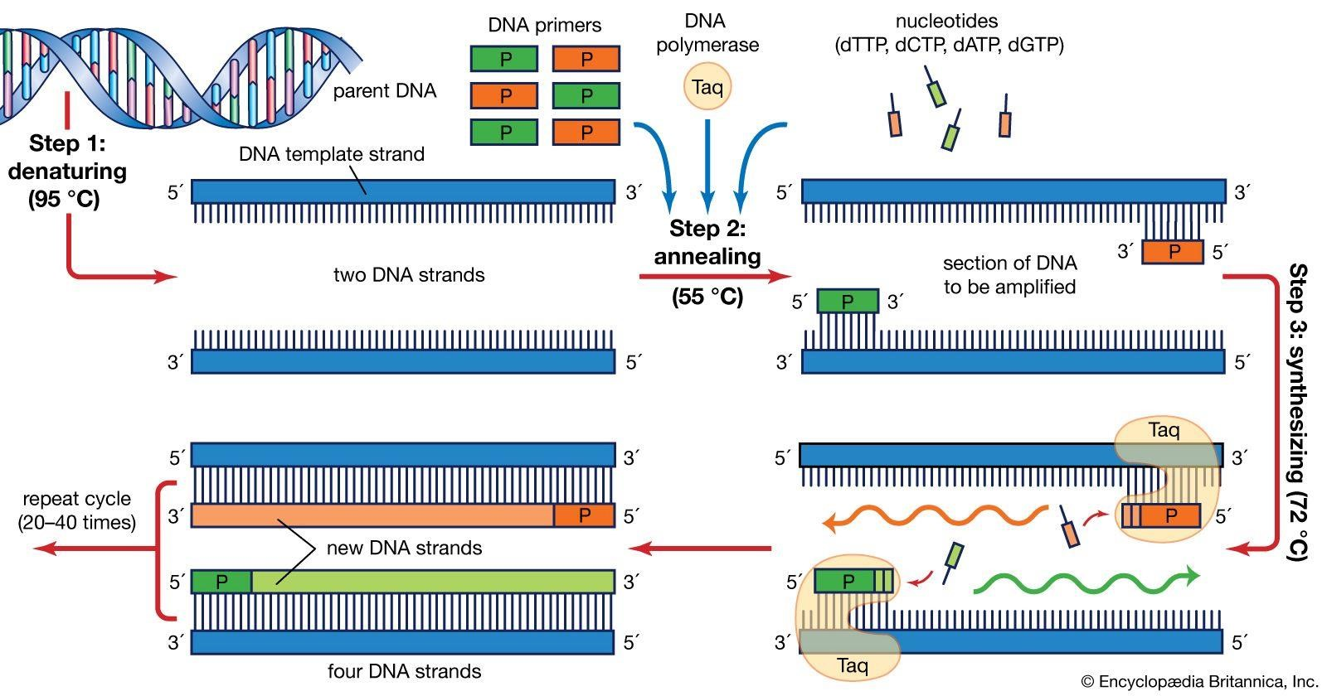

1. **Fragment Separation (Gel or Capillary Electrophoresis)**:

After amplification, the DNA fragments are separated based on their size. This is done through **gel electrophoresis** (commonly with agarose or polyacrylamide gels) or more commonly, **capillary electrophoresis** in automated systems. An electric field is applied, and the negatively charged DNA fragments migrate through the gel matrix or capillary tube. Shorter fragments move faster than longer ones, creating a distinct pattern of bands or peaks.

Fluorescent dyes attached to primers during PCR allow the fragments to be visualized using a laser detector. The output is often shown as an electropherogram, which displays peaks representing different STR alleles at specific loci.

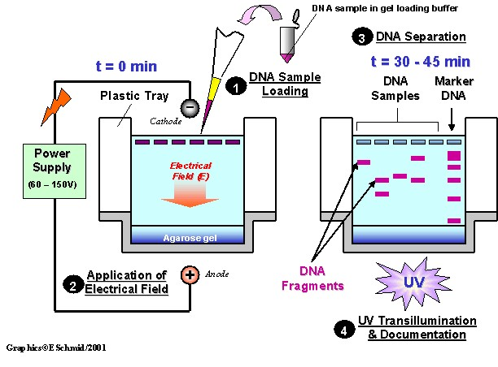

1. **DNA Profile Analysis**:

The final step involves interpreting the DNA profiles. The STR patterns obtained from the electrophoresis results are analyzed to determine the number of repeats at each STR locus. By examining multiple STR loci (typically 13–20 in forensic applications), a highly unique profile can be generated.

The resulting DNA profile can then be compared against another sample (e.g., a suspect's DNA or a database entry) for identification or to determine familial relationships. Statistical methods are used to calculate the likelihood of a random match, often yielding extremely low probabilities, which strengthens the evidentiary value of a match.

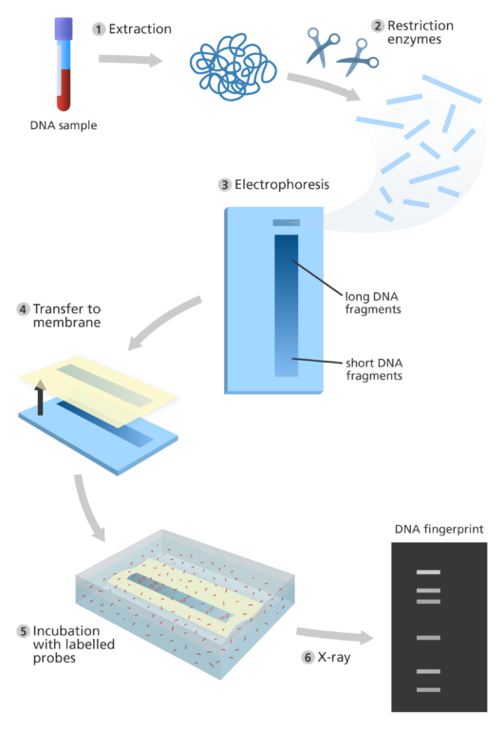

1. **Comparison and Matching**:

The final DNA profile can be compared with other profiles in criminal databases, paternity cases, or identification investigations. A match between profiles can confirm identity or biological relationships with high statistical certainty.

1. **Quality Control and Verification**

Throughout the process, quality control measures are implemented to ensure the integrity of results. This includes the use of positive and negative controls, replication of tests, contamination prevention strategies, and adherence to standard operating procedures (SOPs) and accreditation guidelines.

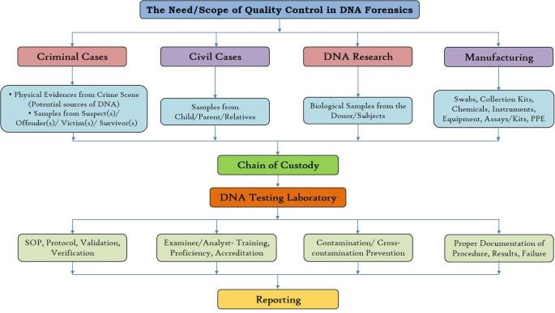

Modern DNA fingerprinting often uses automated systems and software to analyze STR profiles rapidly and accurately. In some advanced settings, additional techniques such as mitochondrial DNA analysis or single nucleotide polymorphism (SNP) profiling may be used for degraded samples or special cases.

### Applications for DNA Fingerprinting

DNA fingerprinting has a wide range of applications across various fields, owing to its high accuracy and reliability in identifying individuals based on their genetic makeup. DNA fingerprinting has found widespread use in both forensic and civil domains. In forensic science, it is used to link suspects to crime scenes, identify remains, and exonerate the wrongly convicted. It is also employed in paternity and kinship analysis, immigration cases, and disaster victim identification. Beyond human applications, the technique has been used in wildlife forensics and conservation biology to monitor endangered species and combat illegal poaching.

Some of the most important and widely used applications include:

1. **Forensic Science**: One of the most prominent uses of DNA fingerprinting is in criminal investigations. It helps in identifying suspects by matching DNA found at crime scenes (such as from blood, hair, or skin cells) with that of a potential suspect. It is also used to exonerate innocent individuals who have been wrongly accused or convicted.

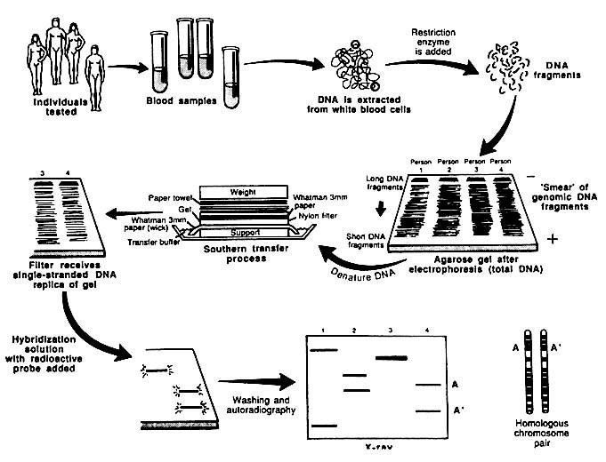

1. **Paternity and Maternity Testing**: DNA fingerprinting is extensively used to determine biological relationships. It can conclusively establish paternity, maternity, or other familial ties by comparing the DNA profiles of the individuals involved.

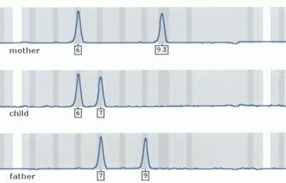

1. **Identification of Missing Persons and Disaster Victims**: In cases of mass disasters, such as plane crashes, earthquakes, or wars, DNA fingerprinting plays a crucial role in identifying bodies that are unrecognizable. It can also help reunite missing people with their families.

1. **Immigration and Citizenship Cases**: In legal cases involving immigration, DNA testing can provide evidence of familial relationships when documents are unavailable or insufficient, helping support applications for family reunification.

1. **Medical and Genetic Research**: Researchers use DNA fingerprinting to study inherited diseases, track genetic disorders, and understand human genetic diversity. It can also aid organ transplantation by ensuring donorrecipient compatibility.

1. **Wildlife Conservation and Animal Breeding**: In wildlife biology, DNA fingerprinting helps in tracking endangered species, studying genetic diversity, and preventing illegal poaching. In agriculture and animal husbandry, it is used for pedigree verification and selective breeding programs.

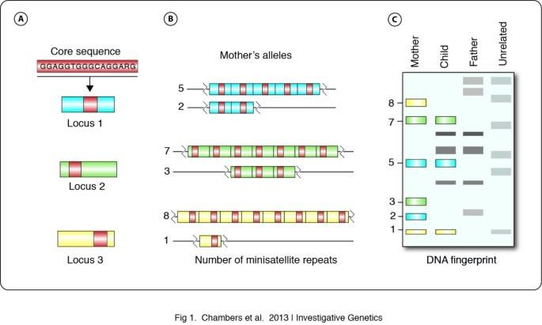

1. **Personal Identification and Biometric Security**: In some high-security environments, DNA fingerprinting is being explored as a biometric tool for identity verification, although privacy and ethical concerns limit its widespread use in this context.

The versatility and scientific robustness of DNA fingerprinting have made it an essential tool across numerous disciplines, where establishing identity or genetic relationships is of paramount importance.

**Advantages and Limitations of DNA Fingerprinting** **Advantages of DNA Fingerprinting:**

1. **High Accuracy and Reliability**: DNA fingerprinting is one of the most precise methods for identifying individuals. Each person’s DNA is unique (except for identical twins), and the probability of two unrelated individuals having the same DNA profile is extremely low, making it highly reliable for identification.

1. **Non-Invasive Collection**: DNA can be extracted from a variety of noninvasive biological samples, such as hair, saliva, or skin cells. This makes the technique useful in a wide range of situations where other forms of identification may be difficult or impossible.

1. **Use in Forensic Investigations**: One of the most significant contributions of DNA fingerprinting has been to forensic science. It is instrumental in solving crimes, matching suspects to crime scene evidence, and exonerating innocent individuals, providing a strong legal tool in criminal justice.

1. **Effective in Identifying Biological Relationships**: DNA fingerprinting can be used to establish biological relationships, such as paternity, maternity, or sibling relationships, with a high degree of certainty. It has revolutionized family law, helping resolve disputes regarding biological connections.

1. **Versatility in Applications**: Beyond law enforcement, DNA fingerprinting is valuable in areas like wildlife conservation, medical research, genetic disorders, and immigration, making it a versatile and essential tool across multiple fields.

1. **Ability to Work with Degraded Samples**: Advanced methods like PCR can amplify even very small or degraded DNA samples, which makes DNA fingerprinting particularly useful in situations where only trace amounts of DNA are available, such as in ancient remains or crime scene evidence.

**Limitations of DNA Fingerprinting:**

1. **Cost and Time-Consuming**: Although DNA fingerprinting has become more affordable over time, the process can still be expensive, particularly for large-scale or high-volume testing. The procedures, including DNA extraction, amplification, and analysis, require specialized equipment and expertise, which can make it time-consuming.

1. **Ethical and Privacy Concerns**: The use of DNA fingerprinting raises significant ethical and privacy issues, especially in terms of genetic data storage and sharing. Unauthorized access to genetic information could lead to potential misuse, discrimination, or invasion of privacy.

1. **Possible Errors in Interpretation**: Although DNA fingerprinting is highly accurate, errors can still occur in the laboratory due to contamination, mishandling of samples, or human error during the interpretation of results. Misinterpretation of DNA profiles can lead to false conclusions.

1. **Identification of Identical Twins**: Identical twins share nearly identical DNA, making it impossible to distinguish between them using standard DNA fingerprinting. This limitation poses challenges in cases where the identification of one twin is necessary, but the twins’ DNA profiles are indistinguishable.

1. **Not Foolproof for Certain Types of Crimes**: While DNA fingerprinting is incredibly useful in many cases, it cannot always solve every crime. Some crimes, like those without biological evidence or where DNA is not available, may not be solvable with this method. Additionally, errors such as contamination at the crime scene can sometimes lead to misleading results.
2. **Legal and Regulatory Issues**: The collection and use of DNA evidence must adhere to strict legal and regulatory standards. Inconsistent legal frameworks, differing regulations across countries, and challenges related to consent for DNA testing can complicate its use in certain situations.

Despite its limitations, the advantages of DNA fingerprinting far outweigh the challenges, making it an indispensable tool in modern science and law enforcement. As technology continues to evolve, some of these limitations may be addressed, further expanding its applications and effectiveness.

### Case Studies of DNA Fingerprinting

DNA fingerprinting has played a pivotal role in many landmark legal and scientific cases. Below are a few notable case studies where DNA fingerprinting has had a profound impact:

1. **The Colin Pitchfork Case (1986) – First Use in Forensic Science**

One of the most famous early uses of DNA fingerprinting was in the case of Colin Pitchfork, a man convicted of two brutal murders in England. In 1986, two young women were raped and murdered in Leicestershire. Initially, a man named Richard Buckland was wrongfully accused and confessed to the crimes, but DNA evidence later revealed his innocence.

The breakthrough came when Sir Alec Jeffreys, the inventor of DNA fingerprinting, was approached by the police to help with the investigation. Using DNA samples taken from the crime scenes, Jeffreys identified the genetic profile of the perpetrator, which did not match Buckland. The police then used DNA fingerprinting to narrow down potential suspects and ultimately found that Colin Pitchfork had a matching DNA profile.

Pitchfork was arrested, and in 1988, he became the first person in the world to be convicted of a crime based on DNA fingerprinting. This case marked the beginning of DNA fingerprinting’ s widespread use in forensic science, demonstrating its power to both solve crimes and exonerate the innocent.

1. **The O.J. Simpson Trial (1995) – DNA Evidence in a High-Profile Murder Case**

Another landmark case in the history of DNA fingerprinting was the O.J. Simpson murder trial in 1995, where DNA evidence played a significant role. Simpson, a former NFL player and actor, was accused of murdering his ex-wife, Nicole Brown Simpson, and her friend Ronald Goldman.

During the trial, the prosecution presented DNA evidence from the crime scene, including blood samples found at the scene of the murders, on Simpson’s car, and on a pair of gloves. The defense team, however, challenged the evidence, suggesting contamination, mishandling, or mishandling of the samples.

Although Simpson was ultimately acquitted of the murders, the case drew significant attention to the power and potential limitations of DNA fingerprinting in the courtroom. The trial brought DNA evidence into the public spotlight, showcasing how genetic profiling can be used both to incriminate and to cast doubt on guilt.

1. **The Exoneration of Kirk Bloodsworth (1992) – Wrongful Conviction and DNA Evidence**

Kirk Bloodsworth’s case is one of the most famous instances of wrongful conviction being overturned through DNA fingerprinting. In 1985, Bloodsworth was convicted of the rape and murder of a nine-year-old girl in Maryland, based largely on eyewitness testimony and physical evidence. He was sentenced to life in prison.

In 1992, DNA evidence, which was not available at the time of his conviction, was used to reexamine the case. The results conclusively proved that Bloodsworth was innocent of the crime. His conviction was overturned, and he was released from prison after serving almost nine years for a crime he did not commit. This case was one of the first to highlight the role of DNA evidence in exonerating wrongly convicted individuals, leading to the establishment of programs like the Innocence Project, which works to free individuals who have been unjustly imprisoned using DNA evidence.

1. **The "Buck v. Davis" Case (2017) – DNA Evidence in a Capital Punishment Case**

In the case of "Buck v. Davis" in 2017, DNA evidence played a critical role in a death penalty case in Texas. Duane Buck was convicted of murder in 1997, and during his trial, an expert witness testified that Buck’s race (African American) made him more likely to commit violent crimes. This racially biased testimony was used to influence the jury’s decision to sentence Buck to death.

Years later, DNA evidence and new research on racial bias in forensic testimony led to calls for Buck’s sentence to be reconsidered. The case ultimately went to the U.S. Supreme Court, which ruled in favor of Buck, ordering that he be granted a new sentencing hearing. While DNA fingerprinting wasn’t directly involved in the case, it was part of a broader movement in forensic science that continues to evolve and highlights the importance of fair and accurate legal processes, especially in cases involving capital punishment.

1. **The Case of the Unknown "Golden State Killer" (2018)**

One of the most remarkable and recent applications of DNA fingerprinting was the identification of the Golden State Killer, a serial murderer and rapist responsible for crimes in California in the 1970s and 1980s. The case had remained unsolved for decades until 2018, when investigators used DNA evidence uploaded to a genealogical database, not a traditional criminal DNA database, to track down a distant relative of the killer.

By comparing DNA left at crime scenes with publicly available genetic data, police were able to identify Joseph James DeAngelo, a former police officer, as the suspect. DeAngelo was arrested, and in 2020, he pleaded guilty to multiple counts of murder and rape, finally bringing justice to his victims. This case showcased the growing role of consumer DNA databases and genealogical tools in solving cold cases, marking a new frontier for the application of DNA fingerprinting.

### Conclusion of Case Studies

These case studies exemplify the profound impact that DNA fingerprinting has had on the justice system, both in solving crimes and in ensuring the fair treatment of individuals. From its role in the conviction of offenders to its use in exonerating the innocent, DNA fingerprinting has transformed forensic science and has become an indispensable tool for law enforcement worldwide. As technology continues to advance, it is likely that DNA fingerprinting will play an even larger role in solving crimes and protecting the rights of individuals.

### CONCLUSION

DNA fingerprinting has revolutionized the fields of forensic science, law, genetics, and many other disciplines by providing a reliable, precise, and powerful method of identifying individuals and solving complex cases. Since its development in the 1980s, DNA fingerprinting has become an indispensable tool in criminal investigations, paternity testing, and the resolution of legal disputes. It has also significantly contributed to the exoneration of wrongly convicted individuals, demonstrating its potential to promote justice and fairness.

While the technique has its limitations—such as ethical concerns, cost, and the inability to distinguish between identical twins—it continues to evolve with technological advancements, making it faster, more efficient, and more accessible. The continued refinement of DNA fingerprinting, including the use of advanced genetic databases and improved analysis methods, ensures that it will remain a cornerstone of modern science and the justice system.

As the applications of DNA fingerprinting expand, including in genealogical research, wildlife conservation, and medical genetics, it is clear that the technique will continue to play a crucial role in understanding human identity and relationships, improving public safety, and fostering justice. However, it remains essential to balance these advances with appropriate ethical guidelines, legal frameworks, and safeguards to protect privacy and human rights.

In conclusion, DNA fingerprinting represents one of the most significant scientific advancements in modern history, with the potential to change lives, bring justice, and provide invaluable insights into human biology and relationships.

**SUMMARY**

DNA fingerprinting, also referred to as DNA profiling or genetic fingerprinting, is a highly precise molecular technique used to identify individuals based on variations in their genetic code. Since its pioneering development in 1984 by Sir Alec Jeffreys at the University of Leicester, DNA fingerprinting has had a transformative impact across multiple fields including forensic science, medicine, legal studies, and wildlife conservation. The foundational principle of DNA fingerprinting lies in the analysis of specific, highly variable regions of DNA known as short tandem repeats (STRs) or variable number tandem repeats (VNTRs), which differ from person to person and serve as unique genetic markers.

The methodology typically involves several critical steps: collecting biological samples (such as blood, saliva, or hair), extracting DNA from these samples, amplifying targeted DNA sequences through polymerase chain reaction (PCR), separating the DNA fragments using gel or capillary electrophoresis, and finally analyzing the banding patterns or electropherograms to create a DNA profile. Because everyone’s DNA—excluding identical twins—is unique, these profiles can be used to match biological material to a specific person with a high degree of certainty.

DNA fingerprinting has found wide application in criminal investigations, where it is used to both identify suspects and exonerate the innocent. It is also extensively used in paternity and maternity testing, immigration cases, disaster victim identification, and genetic research. Landmark cases such as the conviction of Colin Pitchfork in 1986, the first criminal case solved using DNA evidence, and the exoneration of Kirk Bloodsworth in 1992, the first American sentenced to death to be released due to DNA testing, highlight the profound influence this technology has had on the legal system.

Despite its many advantages, DNA fingerprinting is not without limitations. Issues such as sample contamination, interpretation errors, cost, and ethical concerns regarding genetic data privacy must be carefully considered. Furthermore, while highly effective, the method cannot distinguish between identical twins and may require supplementary data for conclusive results in complex cases.

As the technology continues to evolve—becoming faster, more cost-effective, and more accessible—the scope and reliability of DNA fingerprinting are expected to expand even further. With the integration of advanced techniques like nextgeneration sequencing and the growing use of genetic databases, DNA fingerprinting remains one of the most powerful tools for human identification, bridging the gap between science and justice.

### REFERENCES

* Budowle, B., Eisenberg, A. J., & Green, R. L. (2014). Next-generation sequencing in forensic science: Its potential and challenges. *Forensic Science International*, 241, 35-42. <https://doi.org/10.1016/j.forsciint.2014.05.022>

* Butler, J. M. (2005). Forensic DNA typing: Biology and technology behind STR markers (2nd ed.). Elsevier Academic Press.

* Gill, P., Brenner, C. H., & Foreman, L. A. (2006). DNA profiling in forensic science: Advances and challenges. *Forensic Science International*, 156(2-3), 78-86. https://doi.org/10.1016/j.forsciint.2005.12.031

* Harris, M. (2011). DNA databases and privacy: A critical review of the ethical implications. *Journal of Law and Medicine*, 18(3), 319-328.

* Jeffreys, A. J. (1985). DNA fingerprinting. *Nature*, 316, 76-79.

https://doi.org/10.1038/316076a0

* Jobling, M. A., & Gill, P. (2004). The purposes and applications of DNA profiling. *Forensic Science International*, 139(2-3), 123-129.

https://doi.org/10.1016/j.forsciint.2003.11.039

* Kaye, D. H. (2006). DNA identification, privacy, and civil liberties. *Texas Law Review*, 84(6), 1259-1284.

* Krimsky, S. (2006). Genetics and the ethical dilemmas of DNA databases.

*Journal of Law, Medicine & Ethics*, 34(3), 440-449. https://doi.org/10.1111/j.1748-720X.2006.00049.x

* Mullis, K., & Faloona, F. (1987). Specific synthesis of DNA in vitro via a polymerase-catalyzed chain reaction. *Methods in Enzymology*, 155, 335350. https://doi.org/10.1016/0076-6879(87)55023-6

* Palsbøll, P. J., Allen, J. B., & Harkness, J. (2007). Wildlife forensics: Genetic analysis of poaching and endangered species. *Molecular Ecology*,

16(10), 2675-2683. https://doi.org/10.1111/j.1365-294X.2007.03411.x